# Monday

## 9:15-10:00 Fixing bug that blocks my clipboard

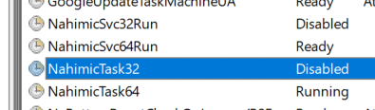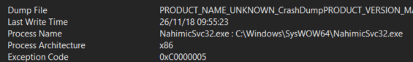

I’ve fixed the crash reports by disabling these programs from starting up. Now my clipboard won’t be overwritten

## 10:00-10:30 Finish up sprint week 1

## 10:30-?:?? The program won’t compile because of an unresolved external symbol

Lots of stuff happened. Most of them were problems with my computer for some reason. Installing a software made it go away.

## 15:00-20:00 Start reading Fundamentals of Computer Graphics

# Tuesday

I’ve been taking care of my little brother today

## 17:30-19:00 Research what completing the square is

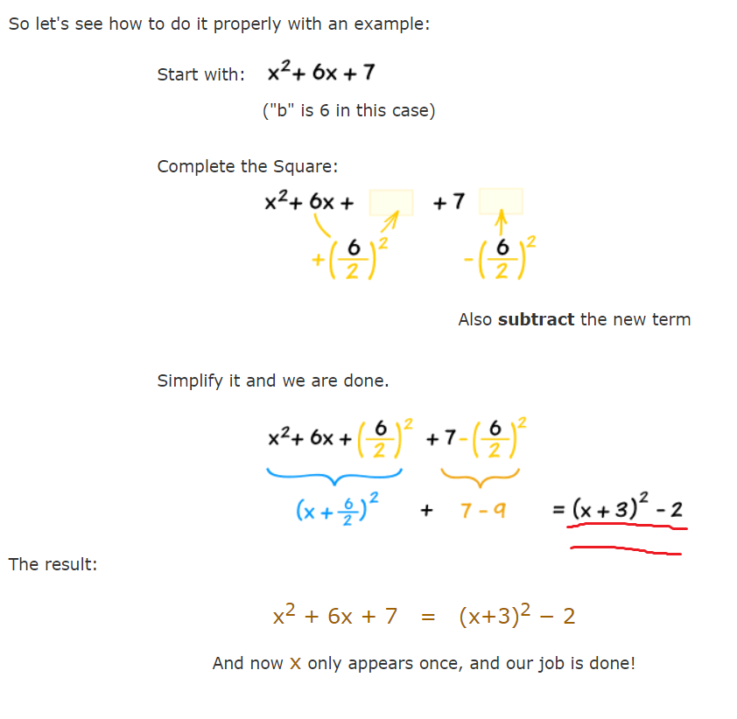

I don’t understand how the equation right of the formula is made up. I think the tutorial is incomplete. [This is the solution I came up](https://drive.google.com/open?id=1srmWBoiKcZcpjGgEkxWSVH6UFHHqxZy_).

## 20:00-20:30 Continue reading Fundamentals of Computer Graphics

# Wednesday

## 8:30-9:00 Fill out daily planning

## 9:00-10:15 Learn completing the root and create quadratic solver formula myself

## 17:15-19:15 Read Fundamental of CG

Don't understand use of section 2.4.5

Read chapter 2 till 2.5

# Thursday

## 6:45-7:05 Fill out daily planning

## 7:05-8:15 Read chapter 4 of Fund CG

Writing down what I've learned really helps me consider what I’ve just learned. It sounds obvious, but most of the time all the terms are glossed over. This really helps to remember them.

This is section 4, 4.1 and 4.2.

* Rendering is the process of taking a collection of object and turning them into an array of pixels
* There are two ways of rendering. Object order and image order. The first check all the objects in turn and checks which pixels it influences. Image order checks each pixel in turn and checks which objects influences that pixel. Both have pros. It is easier to render reflection and shading in image order for example. Ray tracing is an image order rendering algorithm.
* Ray tracing involves 3 steps
  1. Ray generation: calculate ray origin and direction.
  2. Ray intersection: find the closest object that the ray intersects with.
  3. Shading: use information like point of collision, normal and other information to calculate a new ray that decides the color of the pixel.
* Chapter 10 discusses more advanced shading techniques
* Chapter 12 discusses efficient ray tracing.
* Chapter 13 discusses different types of ray tracers.
* To implement perspective, the standard approach is called **linear perspective**. We project the 3D objects onto a 2D **image plane** by having straight lines in the scene become straight lines in the image plane. We can do this by using a technique called **parallel projection**. 3D points are mapped to 2D by moving them along a projection direction. If the projection direction is perpendicular to the image plane, the projection is called orthographic, else it is called oblique.
* **Perspective projection** looks more natural. It differs from parallel projection because instead of projecting points along the lines of the projection direction (parallel lines), we project along lines that pass through a viewpoint (non-parallel lines). This makes objects further away appear smaller just like irl. In architecture, we use parallel projection because it reserves original sizes, but irl light passes through a single point, not on a plane. Oblique and orthographic also apply for perspective projection.

## 9:00-9:35 Meeting with Phil

* I have lots of doubts about asking certain things because I’m not sure when you show initiative to research yourself. Phil has cleared some things on that subject.
* Discussed a bit about how to approach a project. If you need confirmation, just ask about it but do tell what you’ve tried and why it didn’t work.
* Look at the ILO’s and start addressing them.

## 9:40-10:05 Fill out learning log and update linked ILOs

## 10:05-11:45 Set up a new project for a ray tracer

Keep getting error cannot open a precompiled header file.

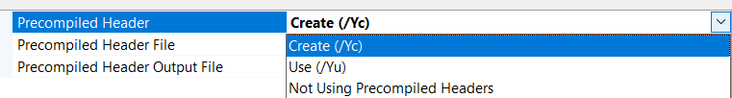

Stdafx is a precompiled header file. If compilation is slow, the compiler will compile this file only once and use it. It first was set on use. Changing it to create solved the problem.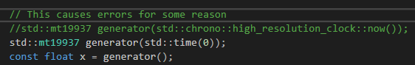

For some reason the chrono call caused errors. It is probably incompatible for some reason. I supplied the time as a seed but I am not sure if this is correct. The program does compile now, however.

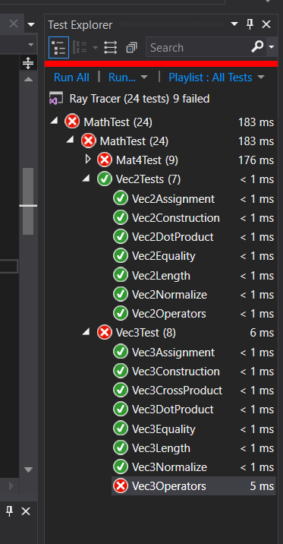

I got the unit test running. It took quite a lot of changing the files around. But now I know how to unit test and that should be very useful. I don’t understand much of it and will ask the teachers.

Either way. I will not modify this further. I got it running, I’ll leave it up to the teachers to fix it. I must focus my attention on the Ray Tracer.

## 11:45-12:30 Helping others set up their unit tests

## 12:45-13:30 Add SFML to the project

## 13:45-16:30 Continue reading Fundamentals of CG

* I’m totally stuck on this part[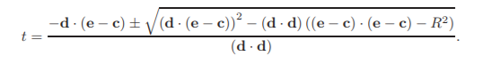](https://drive.google.com/open?id=1xI7sB-S3LNNCjwtz1M5vFubGYkoOUdEk)  
  I don’t understand how this formula is made up. I’m having a hard time wrapping my head around it. While I could just use it, I want to understand it.

## 18:00-18:3190 continue reading Fundamentals of CG

* I'm not sure about it, but an implicit equation is an equation that can't be solved immediately. You need another value. For example (x-xc)= 0 can't be calculated because we don't know the value of x. We do know the value of xc. Basically, you can't separate a variable explicitly. X cos y = y cos x. You can't separate x or y thus this is implicit.

# Friday

## 11:30-12:15 Fill out yesterdays and today's work log

## 12:30-13:15 Try to understand the [formula](https://drive.google.com/open?id=1xI7sB-S3LNNCjwtz1M5vFubGYkoOUdEk)

[My attempt](https://drive.google.com/open?id=1qz0FNzlMj-LdBfIR_Dd30IZAJik9y1t_). I checked it with a calculator and it works. It’s actually really simple, but the author skipped many steps in his calculation. That just shows what they expect.